**CS570 Advance Computer Architecture**

**Homework 3**

1. **Derive the formula for calculating the average access time (AMAT) and the current average access time (C-AMAT) for a word in the first level cache of a system. Assume the following values for a theoretical system containing an L1 cache.**

**Determine the average access time (AMAT) and the current average access time (C-AMAT) for a memory word in the described system.**





1. **What is memory stall time? What is the advantage of the Layered Performance Matching method? Why LPM can improve memory performance (in terms of memory stall time) by more than one hundred times?**

* Having a stall in the pipeline means that the whole processor wastes one or more cycles, causing execution to slow down temporarily. The time that is consumed in stalling is memory stall time.
* The rationale of LPM is that the performance of each layer of a memory hierarchy should and can be optimized to closely match the request of the layer directly above it. The LPM model simultaneously considers both data access concurrency and locality. It reveals the fact that increasing the effective overlapping between hits and misses of the higher layer will alleviate the performance impact of the lower layer.
* The terms pure miss and pure miss penalty are introduced to measure the effectiveness of such hit-miss overlapping. By distinguishing between (general) miss and pure miss, we have made LPM optimization practical and feasible.

1. **The following Figure 1 shows a cycle-accurate C-AMAT example. In this example, there are 10 data accesses in L1 cache. Among these data accesses, data access 1, 3, 5 are hit data accesses, others are miss data accesses. As Figure 1 shows, the green cycles are hit cycles and the black cycles are miss cycles. (hint: please be careful about what is the difference of miss data access and pure miss data access)**

**Figure 1. Cycle-accurate C-AMAT Example**

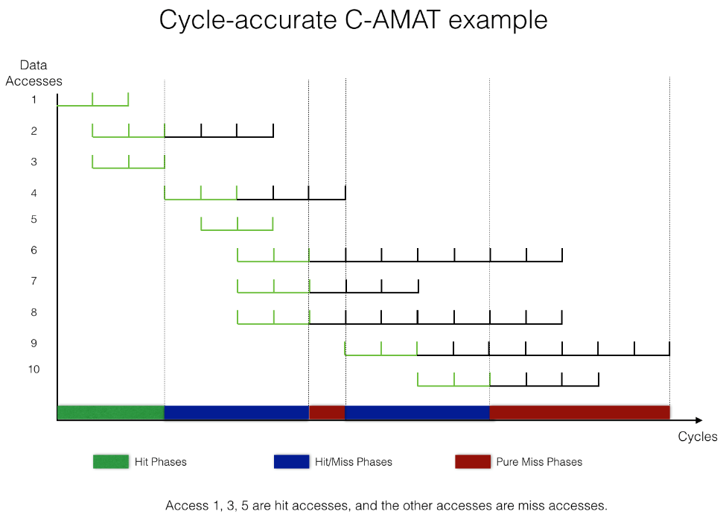

**Please calculate the AMAT and C-AMAT value of this example in this Figure 1.**



1. **In this following table, one set of AMAT and other parameters in L1 cache are given. Is it possible to use the given AMAT and other parameters to calculate C-AMAT in L1 cache? If it is possible, please calculate it and explain why?**



1. **Prove C-AMAT = 1/APC**

* To cover the concurrent read and write properties of modern memory systems, the C-AMAT model is proposed.
* C-AMAT is formulated similar to AMAT, but considers concurrent hit and concurrent pure miss accesses. Quantitatively, C-AMAT is defined as the total memory access cycles (the total number of cycles executed in which there is at least one outstanding memory reference), represented as , divided by the total number of memory accesses, represented as :



*  only includes clock cycles which have memory access activities; thus cycles without any memory references are excluded. This is related to another research work, which defines Access Per Cycle (APC). APC is a performance metric to measure concurrent memory system performance. C-AMAT is the reciprocal of APC:
* The first parameter H is the same as that in AMAT. The second parameter CH represents hit concurrency; the third parameter CM (capital M) represents the pure miss concurrency while the conventional miss concurrency is referred to as Cm (little m). CH can be contributed by caches with multi-port, multi-bank or pipelined structures. CM can be contributed by non-blocking cache structures. In addition, out-of-order execution, multi-issue pipeline, simultaneous multi-threading (SMT), chip multiprocessor (CMP), can all increase CH and CM. The pure miss rate pMR is the number of pure misses over the total number of accesses, which is different from the conventional miss rate (MR). A pure miss here means that a miss contains at least one miss cycle that does not have any hit access activity. pAMP is the average number of pure miss cycles per pure miss access.

* Please notice that the contribution of C-AMAT is not its measurement. The measurement can be obtained directly through APC (Access Per memory active Cycle). The measurement of C-AMAT does not depend on the measurement of its five parameters. The value of the parameters is in performance analysis and optimization. The invaluable contribution of C-AMAT is that it provides a unified formulation to capture the joint performance impact of locality and concurrency.

* The average miss penalty of AMAT can be extended recursively to the next layer of a memory hierarchy. This recursiveness is true for C-AMAT as well. **Eq-(1)** shows the recurrence relation. Here, C-AMAT1 is the L1 C-AMAT and C-AMAT2 is the L2 C-AMAT.  That is extending C-AMAT from the L1 level to L2 level.
* Unless indicated explicitly, the default CAMAT is C-AMAT1. **Eq. (1)** illustrates some interesting and valuable properties of concurrent data accesses: the impact of C-AMAT2 can be mitigated by concurrency, in terms of pMR1 and η1. This potential for penalty mitigation is the theoretical foundation and motivation of the layered matching mechanism proposed in this research.
* Please notice here that we have introduced a new parameter, **κ1**, and the impact of **C-AMAT2** toward the final **C-AMAT1** has been trimmed by **MR1** and **κ1**. Here **MR1** is the locality contribution as given by AMAT; **κ1** is the (hit/miss) overlapping contribution at the L1 level. **κ1** only has one new parameter, **Cm**, which is the miss concurrency.
* Please notice that we use **CM** (capital M) to represent the pure concurrent misses and use **Cm** (little m) to represent concurrent misses. **κ1** is the ratio of the number of pure miss cycles over the number of miss cycles at the L1 level. It is measurable and has a clear physical meaning. **Eq. (1)** is the result of a direct mathematical deduction based on the definition of **C-AMAT1** and **C-AMAT2**, and this deduction, as well as the recursive relation, can be extended to **C-AMAT2** and **C-AMAT3**, **C-AMAT3** and **C-AMAT4**, etc..
* **Eq. (1)** shows overlapping is as important as locality in reducing data access delay, while concurrency hit only increases hit bandwidth but not reduce miss penalty. It unifies and clearly presents the factors of locality, concurrency, and overlapping toward the final memory system performance.

**Equation – (1)**

1. **Describe what is Pace Data Transfer, and explain why the new development of elastic computing architecture and FPGA are in favor of Pace Data Transfer?**

* Pace Data Transfer is a type of data transfer method for removing memory wall effect or problem. Accessing the data is one of the main performance concerns while computing.
* Pace data transfer design is used to optimize memory performance of the system. So the memory- computing hierarchy is built based on the pace matching design in order to generate as well as transfer the final results.
* C-AMAT is used to calculate the ratio of data transfer request and supply and layer performance matching matches the data transfer at each of the memory layer.
* Pace matching data transfer can reduce the memory wall problem and the optimization of the pace data transfer is different from the conventional locality based system optimization. Pace data transfer can reduce up to 150x memory stall time.
* Yes, we can achieve Pace Data Transfer under certain assumptions.The applications should have sufficient data concurrency and the system should have sufficient hardware for supporting the data concurrency. If there are different data accesses patterns for any application the architecture needs to be elastic.

**Challenging Homework (could be part of your term project)**

**C-1. Discuss how data access models can be used in remote data access and message passing? (hint: see slide 5 of Lecture 7)**

* We can use Log(p) model to explain how data access models can be used in remote data access and message passing. Log(p) is a model of distributed-memory multiprocessor in which processors communicate by point-to-point messages. The model specifies the performance characteristics of the interconnection network, but does not describe the structure of the network.
* The main parameters of the model are:

L: an upper bound on the latency, or delay, incurred in communicating a message containing a word (or small number of words) from its source module to its target module.

o: the overhead, defined as the length of time that a processor is engaged in the transmission or reception of each message; during this time, the processor cannot perform other operations.

g: the gap, defined as the minimum time interval between consecutive message transmissions or consecutive message receptions at a processor. The reciprocal of g corresponds to the available per-processor communication bandwidth.

P: the number of processor/memory modules. We assume unit time for local operations and call it a cycle.

* Most importantly, LogP encourages techniques that work well in practice, such as coordinating the assignment of work with data placement, so as to reduce the amount of communication. The model also encourages the careful scheduling of communication and overlapping of computation with communication within the limits imposed by network capacity. The limitation on network capacity also encourages balanced communication patterns in which no processor is flooded with incoming messages.